Long Live the King (and His Manuscripts)
A Story of Ritual and Power from Medieval Kathmandu

Early manuscripts of Sanskrit texts sometimes provide us with details concerning their production, but very little they tell about their use after the copying. Although it is not always easy to gather this sort of diachronic information directly from the manuscripts, there are cases in which these are actually willing to disclose more particulars about their stories to one who looks close enough. An intriguing case is represented by a medieval manuscript from the National Archives of Kathmandu, which shows clear traces of its being used throughout the centuries. What does it tell us about the long life it enjoyed following the end of its copying?

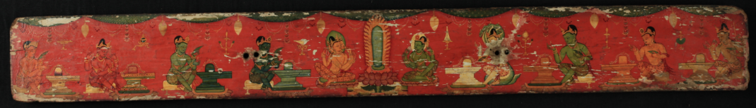
[Image for the start page.]

***

Our manuscript is known under the siglum NAK 1-1075, and consists of 289 palm-leaf folios transmitting eight works dealing mainly with devotional practices addressed to the god Śiva, and with the religious duties of the god’s devotees. These eight texts are commonly known to scholars as “Śivadharma Corpus”, and are often transmitted together in Nepalese multiple-text manuscripts. The manuscript belongs thus to an early and rich tradition, whose specimens span from the 9th to the 20th century.

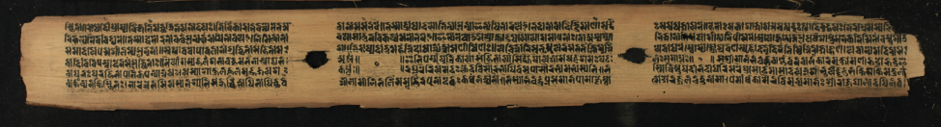
Fig. 1: fol. 290r: conclusion of the Dharmaputrikā, last work of the Śivadharma Corpus, and poem celebrating king Rudradeva

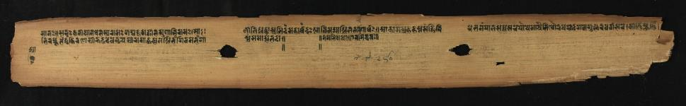
Fig. 3: fol. 290v: conclusion of the poem celebrating king Rudradeva and end of the manuscript

Within this broad timespan, we know exactly where to locate our manuscript thanks to its final colophon, revealing the exact date of its production. The scribe — who refers to himself as “the distinguished [man] named Rāma” (Fig. 1 and 2) – gives the end-date of the copying in the frame of a short poetical composition of his, in which by means of four śārdūlavikrīḍita (“play of the tiger”) stanzas he sings the praises of king Rudradeva, who is “Rudra, like Rudra unrivalled, pursuing the only wealth that is the welfare and opulence of others”. The date of Rudradeva’s reign is ca. 1167-1175 CE, while the manuscript was penned “in the expired Nepalese year named ‘ether-planet-hand’, in the month of Pauṣa and in the 15th lunar day in the bright [fortnight], on the day of the sun, when the king [was] the celebrated Rudradeva, who has obscured the rays of the moon through the breaking forth of [his] fame”, namely on January 4, 1170 CE. The little poem composed for the king and placed at the end of the manuscript makes it possible to surmise a direct connection with Rudradeva or the royal family, which might have acted as sponsors for the production of the manuscript.

Following that day of January in the year 1170, the destiny of this manuscript of the Śivadharma corpus was certainly not to lie unused in an archive. This is already evident by observing its very first folio, whose recto side is provided with a table of contents of the works contained in the manuscript, written by a significantly later hand than the one that copied the texts. This table of contents lists the titles, the number of leaves and chapters, as well as a short version of the incipit of each work. We know therefore that centuries after its production the manuscript was still in use, as somebody felt the need to index and fix its contents, in order to easily find the desired work in the manuscript, and possibly also to avoid any loss to it. One can, however, be more precise in identifying at least one of the uses that this manuscript underwent, as well as to fix a time in history when this object was still alive.

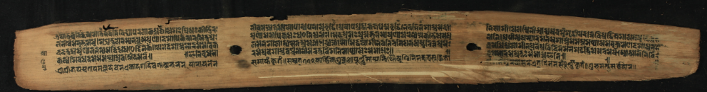
Fig. 1: . Fol. 254v: Colophon attesting the public reading of the manuscript under king Pratāpamalladeva of Kathmandu

On fol. 254v (Fig. 1) it is possible to detect another colophon recording a much later date. This attests that the manuscript was read, in the reign of the king Pratāpamalla of Kathmandu, during a public recitation that lasted eleven days and ended in the “year 772, on the full-moon day of the bright [fortnight] in the [month of] Kārttika, under the asterism of the Aśvin” (November 1651 CE). The manuscript was therefore still being used at that late date, 482 years after its completion, in the ritual readings that are more than once prescribed by the texts of the Śivadharma corpus, especially the Śivadharmottara, and that are also attested in similar records found in other Nepalese manuscripts.

The colophons of our manuscript thus testify to the strong connection existing between its production and use and the monarchical power, having most likely been composed at the behest of Rudradeva, of the rather obscure Ṭhākurī kings, in the second half of the 12th century, and being still used for ritual recitations at least until the reign of Pratāpamalla (r. 1641-1674 CE), whose rulership marks one of the highlights in the history of the Malla dynasty. The idea of a ritual function of the manuscript, also aimed at the celebration of the monarchs who sponsored it, could indeed be a key not only to the study of this specific object, but also to the understanding of two basic features of the many similar manuscripts of the Śivadharma corpus in medieval Nepal: their abundance, counting on more than sixty specimens according to a rough estimate, and their being constantly arranged in multiple-text manuscripts, in which the order given to the works may reflect the prescribed sequence in which the texts were supposed to be read during the ritual. As the final stanza of the Śivadharmottara reads: “Where the king listens to the Śivadharma uninterruptedly, in this place there will always be prosperity for all sentient beings”; the rulers of Nepal seem to have taken this advice seriously, and have put it into practice by granting their support to the emergence and growth of this corpus of texts.

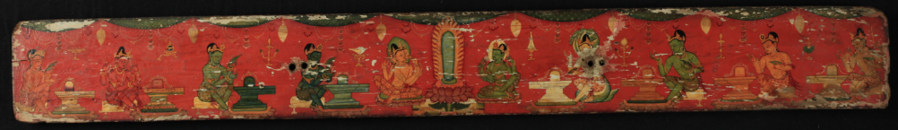
Fig. ?: Wooden cover, front side. Scenes of liṅga adoration.

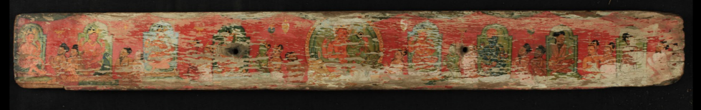
Fig. ?: Wooden cover, back side. Scenes of worship of various deities

References

DE SIMINI, Florinda (forth.). “Śivadharma Manuscripts from Nepal and the Making of a Śaiva Corpus”. Michael Friedrich (ed.), One Volume-Libraries: Composite and Multiple-text Manuscripts. Berlin, DeGruyter.

PETECH, Luciano (1984).² Mediaeval History of Nepal (c. 750-1482). Roma, Istituto Italiano per il Medio ed Estremo Oriente (Is.Me.O). Serie Orientale Roma vol. LIV (first edition: 1958).

Description:
National Archives of Kathmandu
Shelf mark: 1-1075. Nepalese-German Manuscript Preservation Project reel no. B 7/3
Material: palm-leaf. 289 fols. 2 string-holes, 6 lines on a page
Dimensions: 58x6 cm
Provenance: Nepal; January 4, 1170
___________________________________________________________________________________________
Text by Florinda De Simini
© for figs. 1–5: National Archives of Kathmandu

